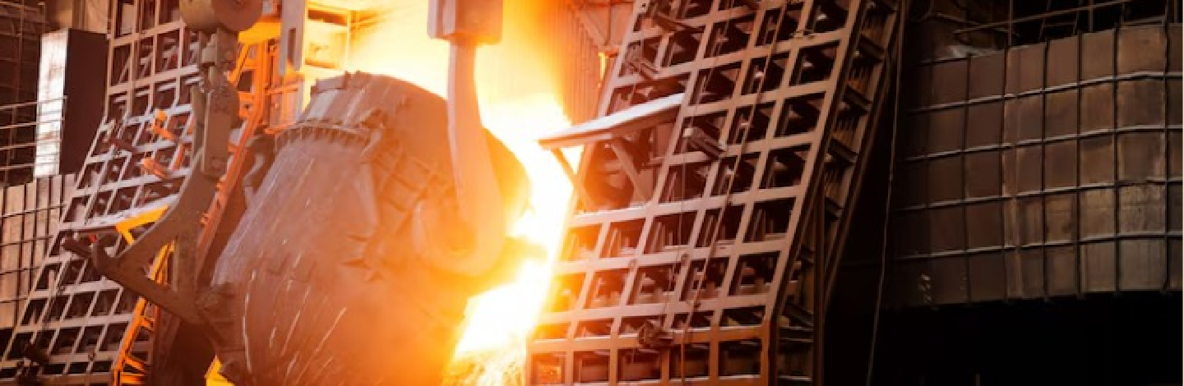
+91 9260006666 sales@sumukhsteelcast.com

HOME ABOUT PRODUCTS INFRASTRUCTURE CLIENT CAREERS BLOGS CONTACT US

Products
ENQUIRY

Our Services

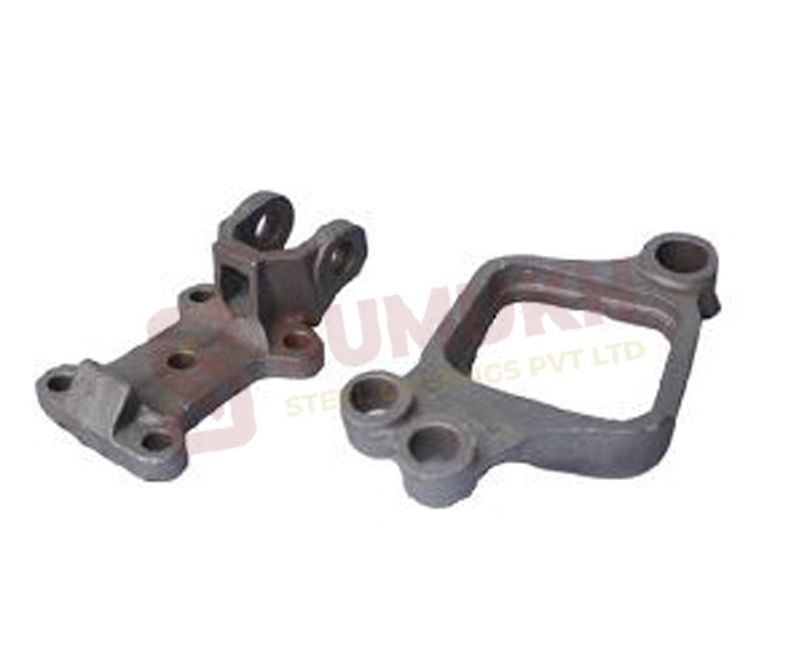  Auto Vehicle Suspension Part |  | 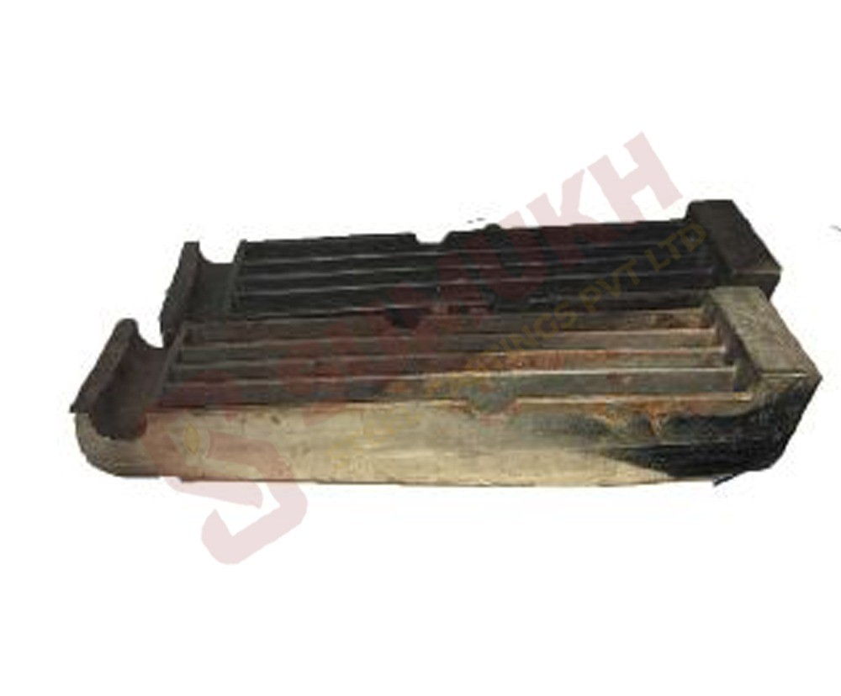  Grate Plate |  | 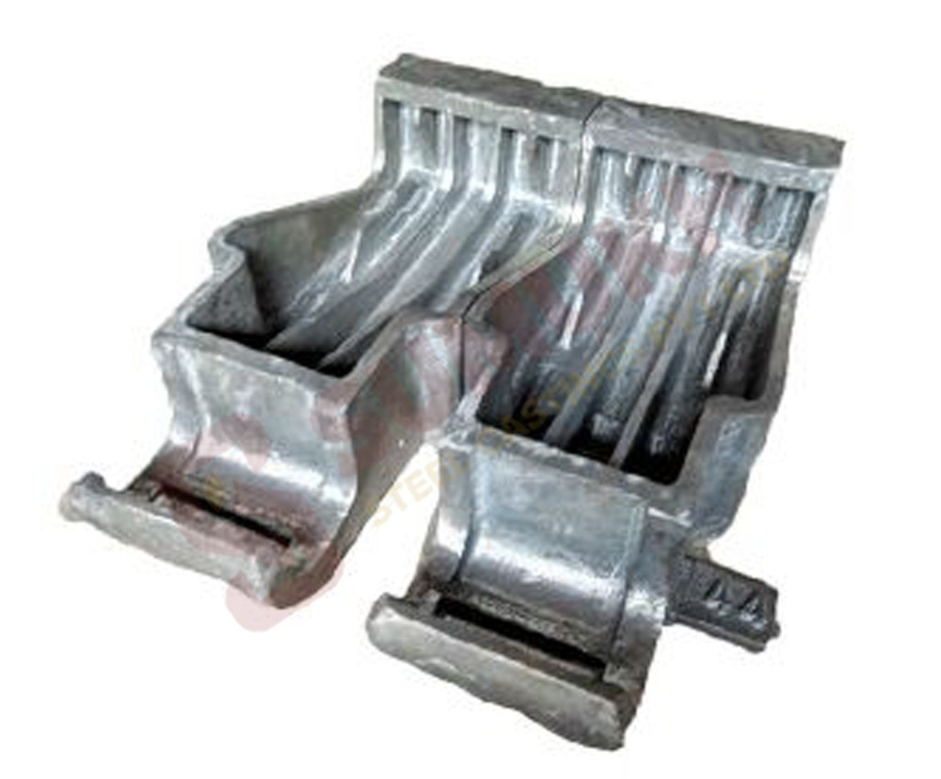  Heat Resistent Grate Plate

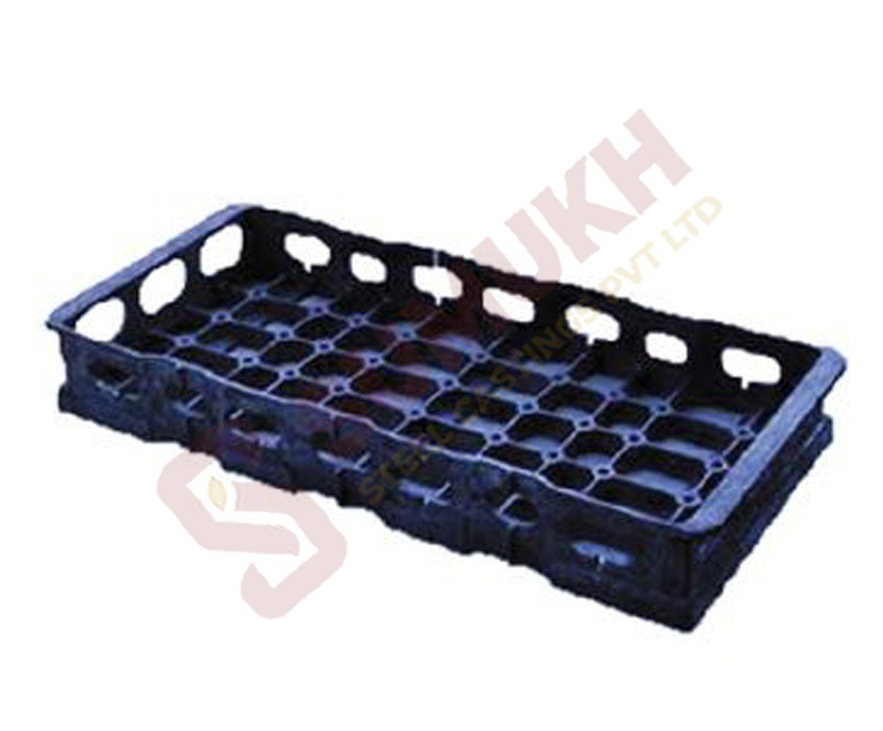  Heat Tratment Trays |  | 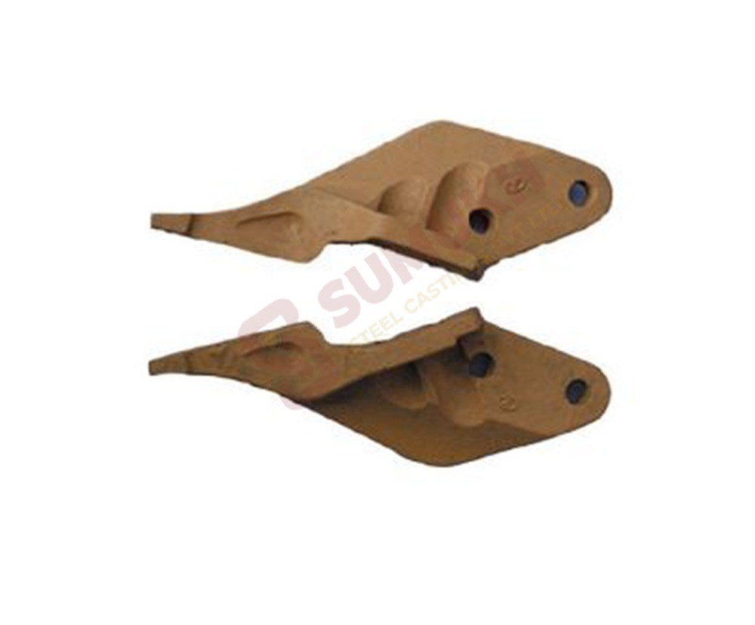  JCB Machine Side Cutter |  | 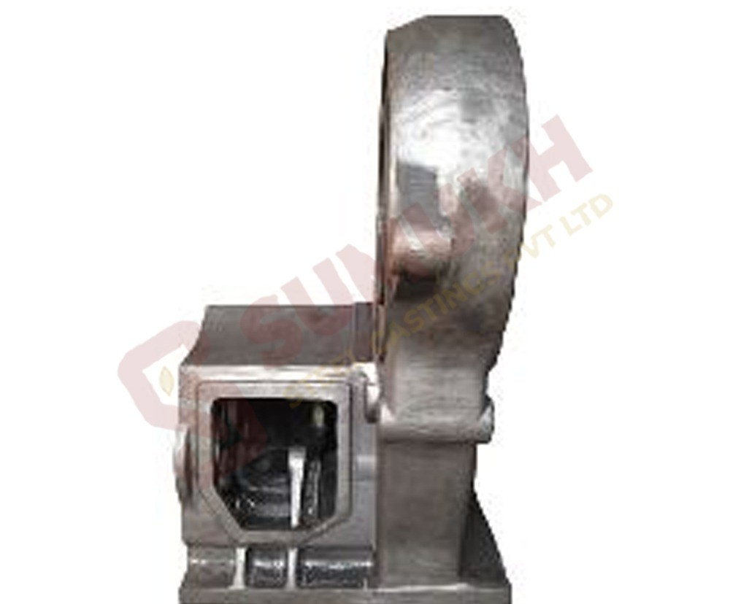  Military Tank Gear Box Casting

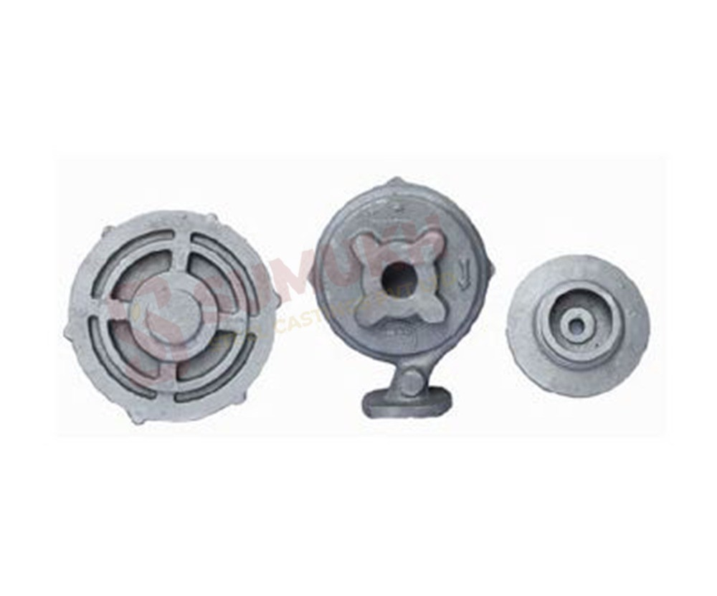  Stainless Steel Casting |  | 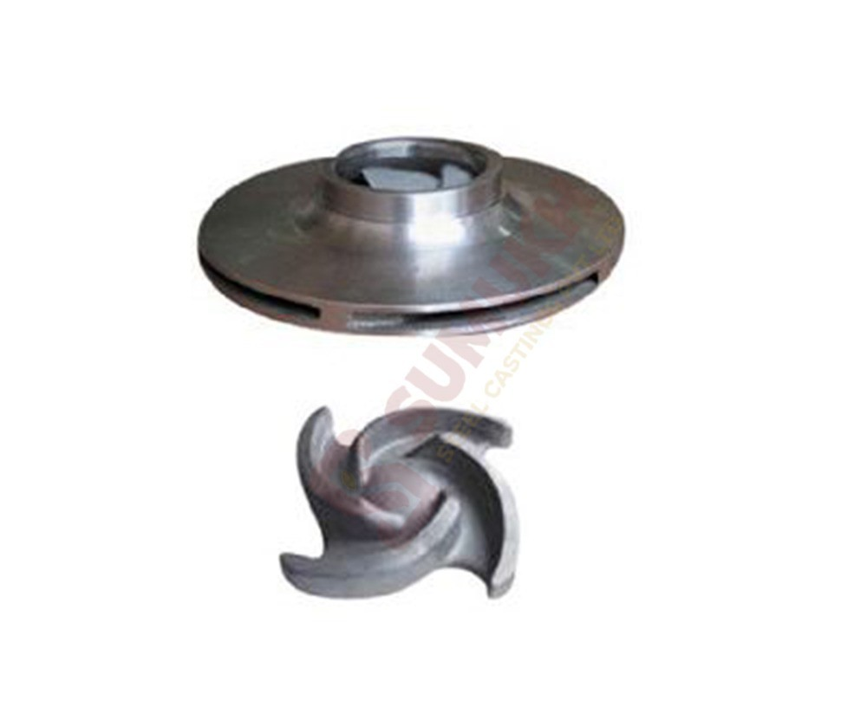  Stainless Steel Impeller |  | 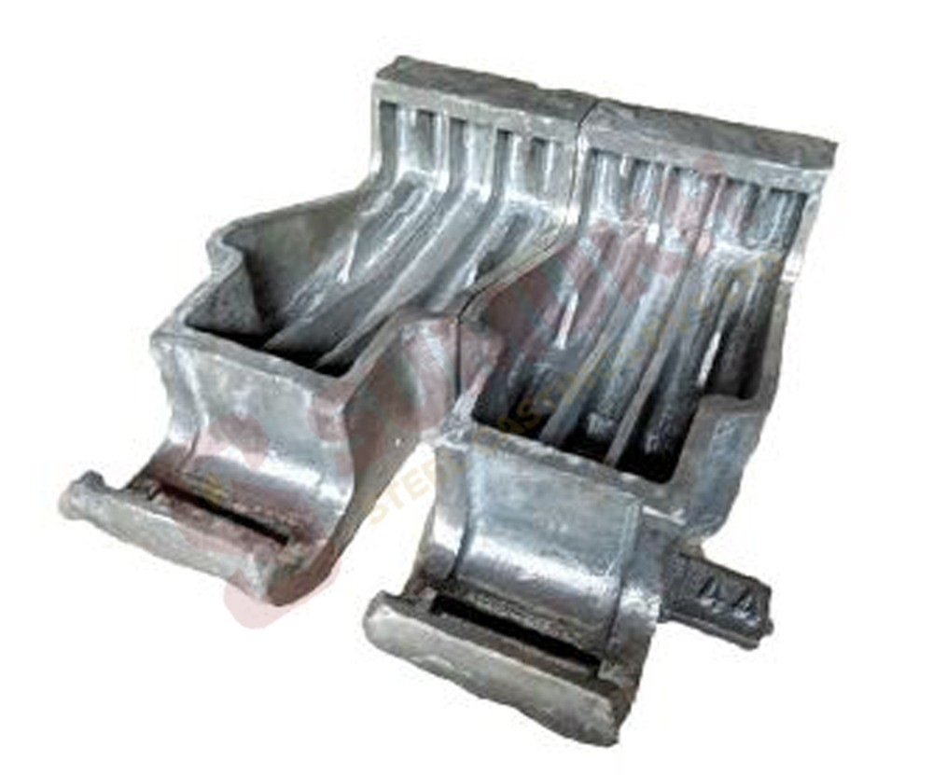  Heat Resistent Grate Plate

Visit us- https://sumukhsteelcast.com/

Our Products- https://sumukhsteelcast.com/products/

Sumukh Steel Casting Pvt Ltd was founded in year 2009 with the aim of supplying best quality steel castings to the industry.

Working Hours: 10 AM to 5 PM

Quick Links
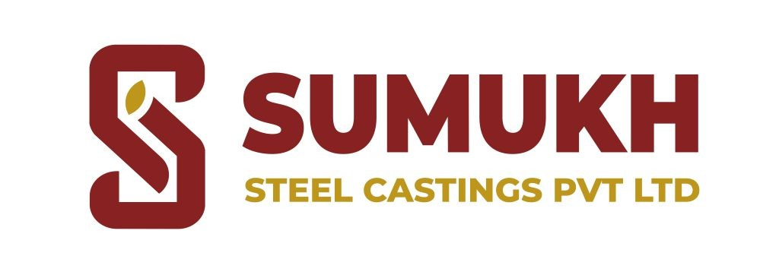

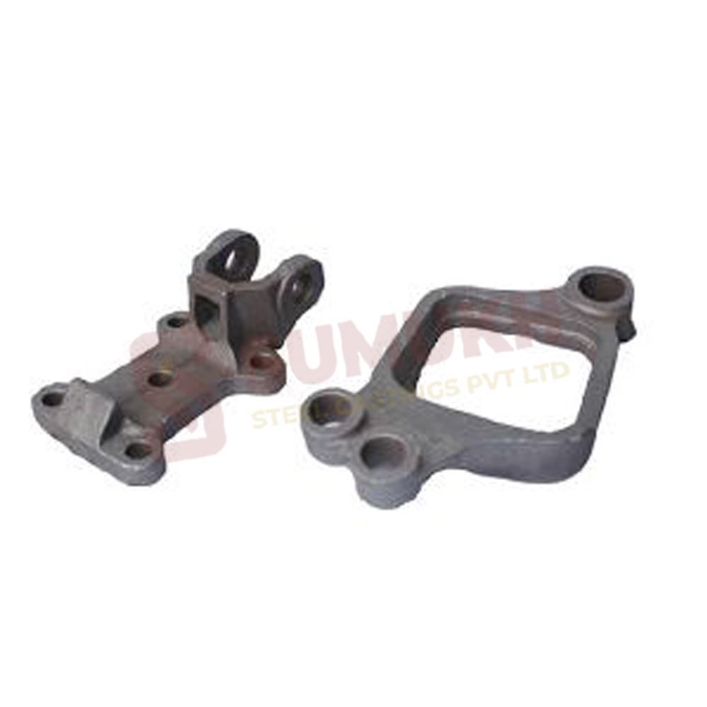
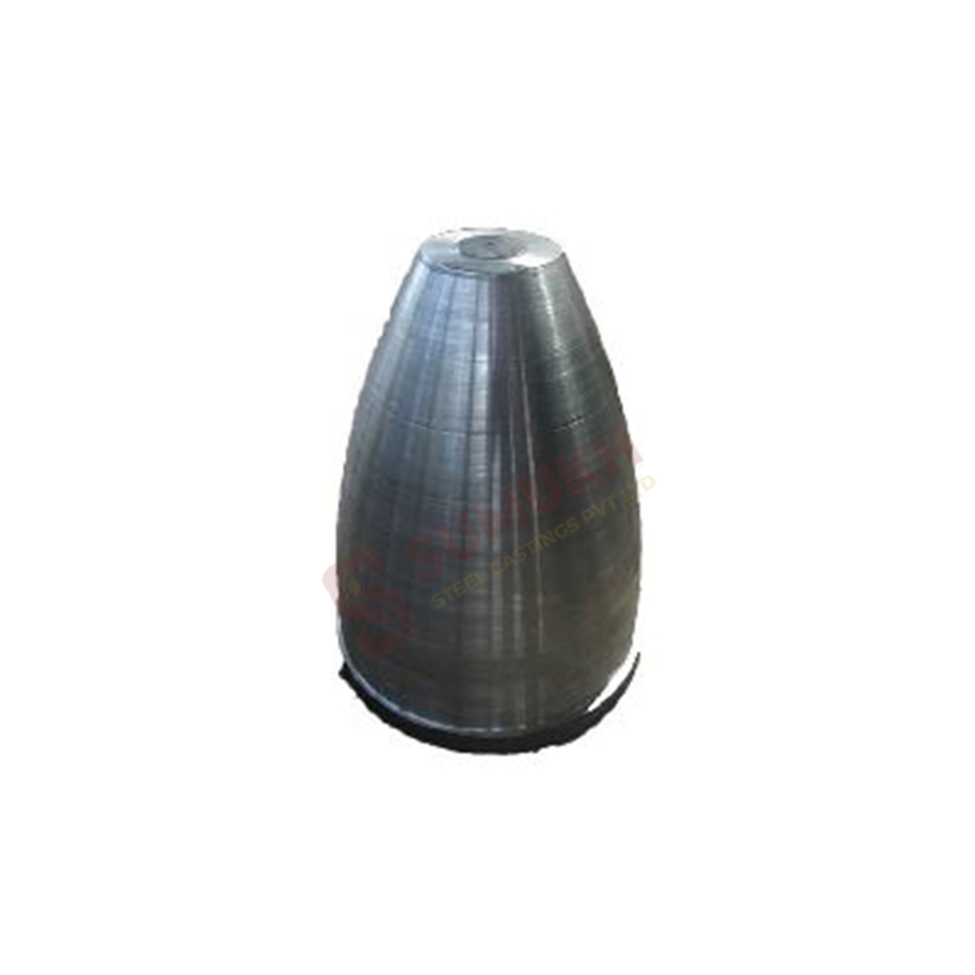
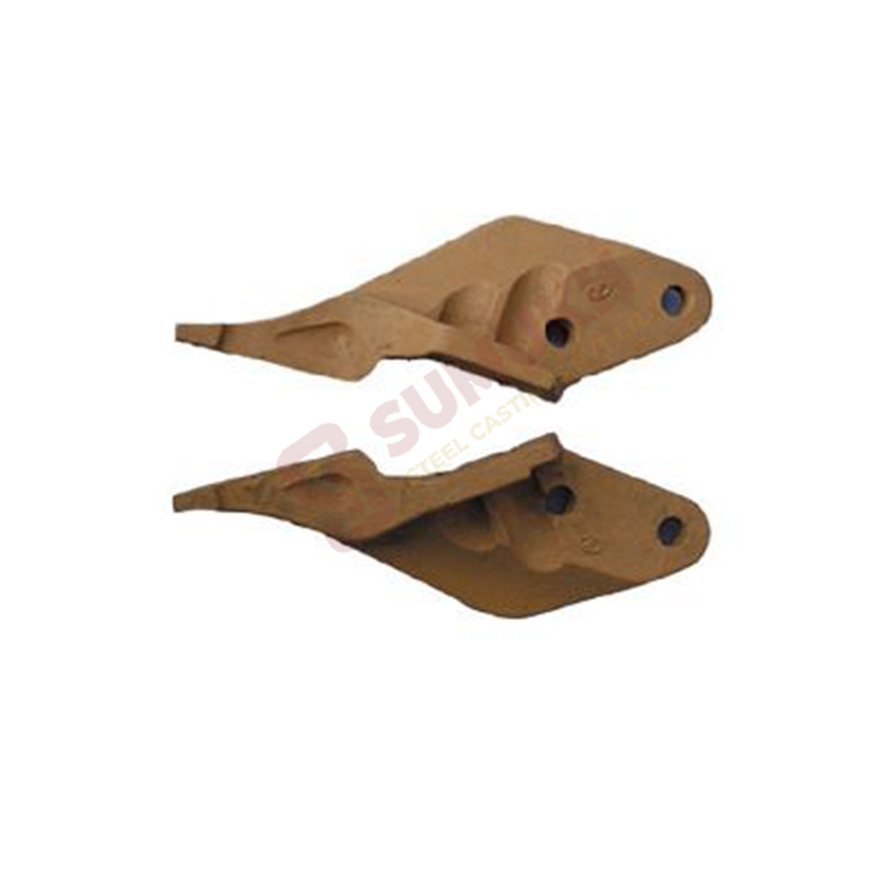
Home About Products
Sumukh Steel Casting Pvt Ltd., 2025 . All Rights Reserved.
Infrastructure Client Careers
Blogs Contact Us

Contact Details
D-6, Gokul Shirgaon MIDC Kolhapur – 416234
dhruv@sumukhsteelcast. com
sales@sumukhsteelcast.c om
+91 9260006666
Our Products

