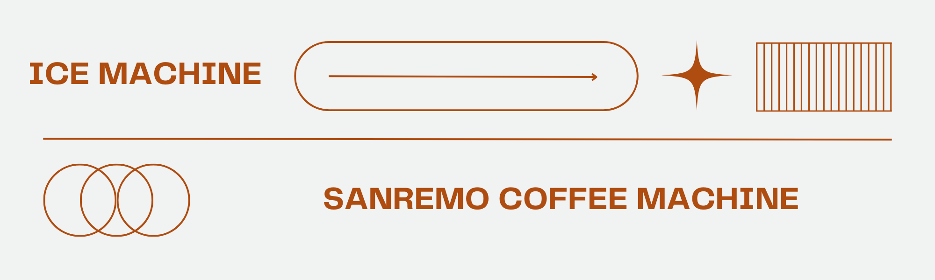

**Why a Sanremo Coffee Machine and Ice Machine Are Essential for Your Café or Business**

When it comes to creating the perfect coffee experience, choosing the right **coffee machine** plays a vital role. A [**Sanremo coffee machine**](https://gcgtrading.com/product-details.html?id=134) is widely recognized for its innovation, reliability, and elegant design, making it a top choice for cafés, restaurants, and even office spaces. With cutting-edge features and precision engineering, it delivers consistent results that enhance the flavor and aroma of every cup, helping baristas craft both traditional espresso and creative specialty drinks with ease.

The advantage of investing in a Sanremo coffee machine is not only its performance but also its long-lasting durability. Built with high-quality materials and user-friendly technology, these machines are designed to handle heavy daily use while maintaining excellent efficiency. Whether you are a professional barista or a business owner aiming to impress customers, this [**coffee machine**](https://gcgtrading.com) ensures a superior brewing experience that sets your service apart from the competition.

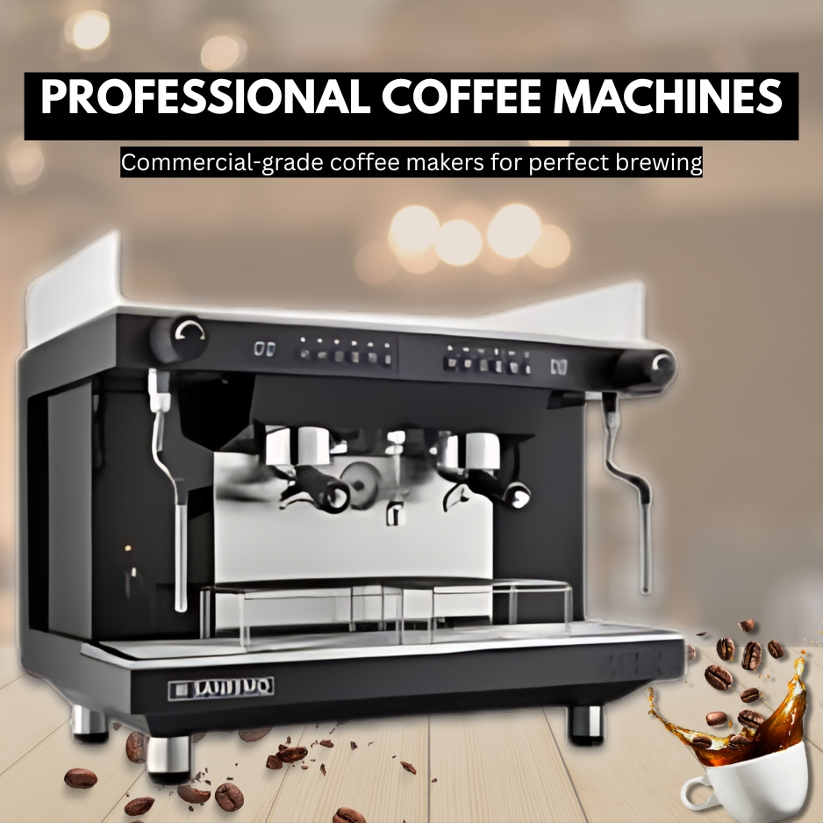

In addition to a powerful coffee setup, having complementary equipment like an [**ice machine**](https://gcgtrading.com/product-details.html?id=155) is essential for modern beverage service. With the increasing demand for iced lattes, cold brews, and refreshing chilled drinks, an ice machine ensures you never fall short of customer expectations. Pairing a Sanremo coffee machine with an efficient ice machine allows you to expand your menu and meet both hot and cold beverage preferences throughout the year.

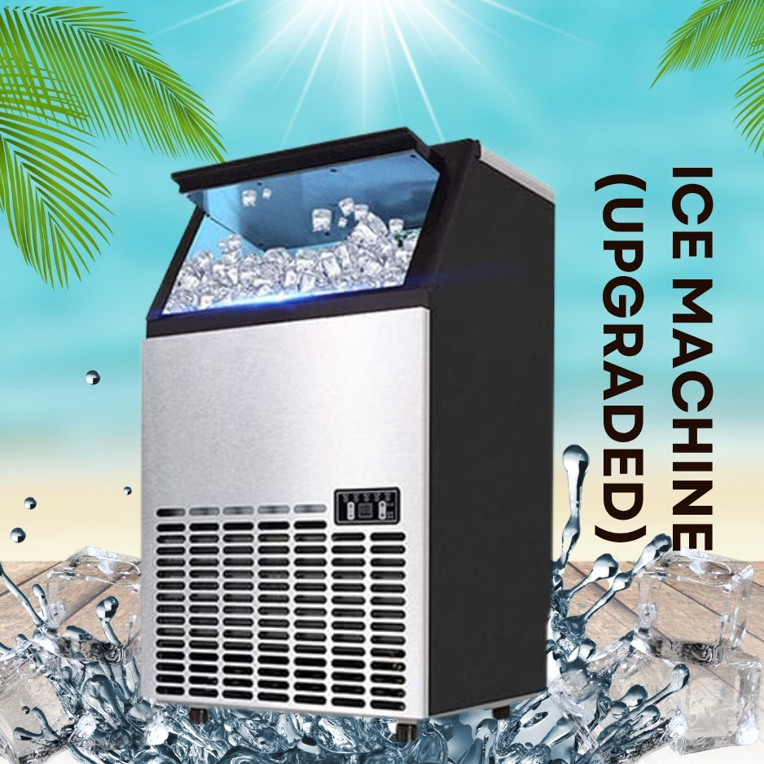

For businesses in the hospitality and food industry, the combination of a Sanremo coffee machine and a reliable ice machine is a smart investment that enhances efficiency and customer satisfaction. Together, they provide the perfect balance of hot and cold beverage solutions, ensuring your café, restaurant, or office can cater to diverse tastes. With these machines, you can deliver exceptional quality, streamline operations, and create memorable experiences for every customer.